Each industry need to inspect their parts to deliver only good part. That’s why we do metrology, to measure, compare and tell if a part is good or not.
What could we do want a part is not valid? We need to rework it, or worst, throw it and make a new one. Anyway, it’s big financial and time costs. When it’s a unique part, we can sometimes use inspection and real-time guidance to be as close as possible to nominal, and more important stay in tolerances. For sure, the goal is the same for series. In this case, the best will be to have good part whatever the different parameters such as but not limited to: Operator, measurement hardware, manufacturing machine, environment…
Therefore, we conduct some repeatability test, generally 10 measures each time we change one parameter. Instrument number 1, part number 1, operator number 1, in piece number 1. Ten measures. And now we need a way to analyze data.

Here what you can do in SA :

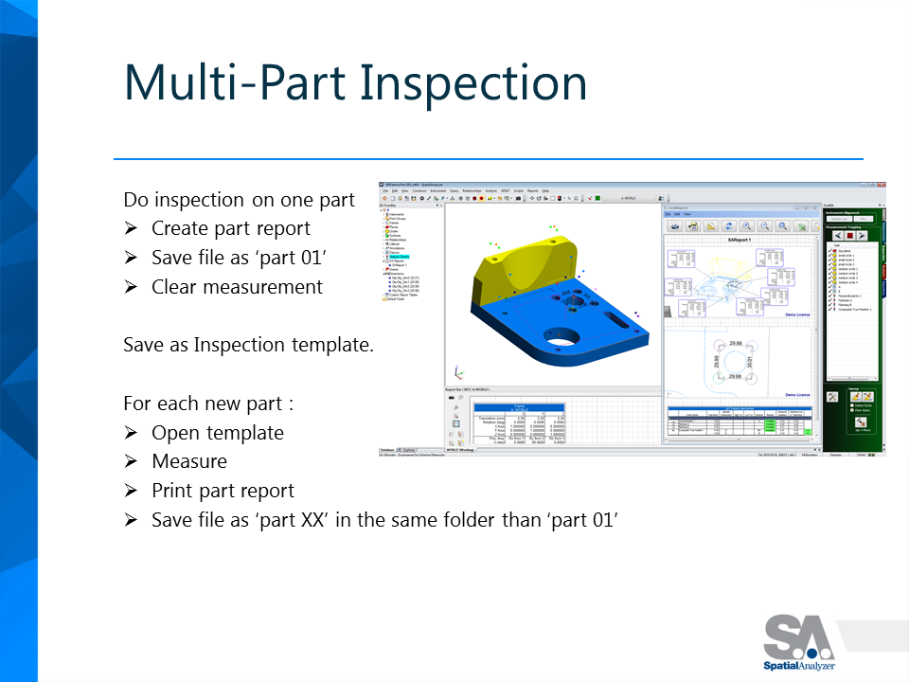

Then, you have 10 files in the same folder, and you are interested to check the different value for some features.
Open a new SA file, then:
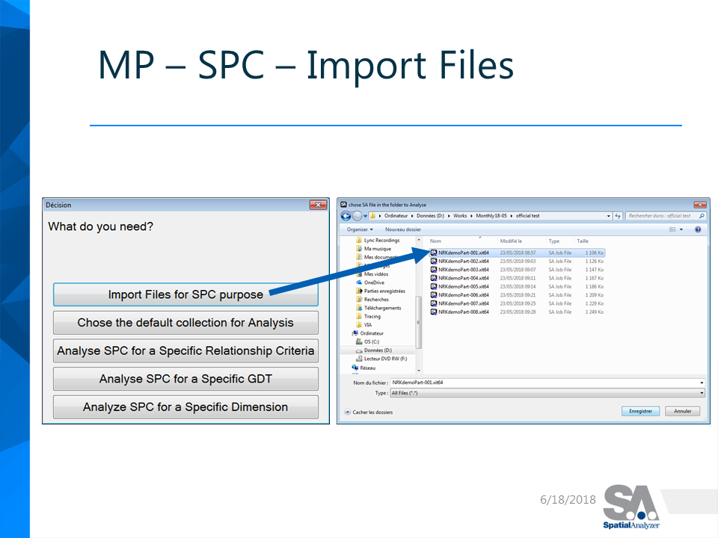
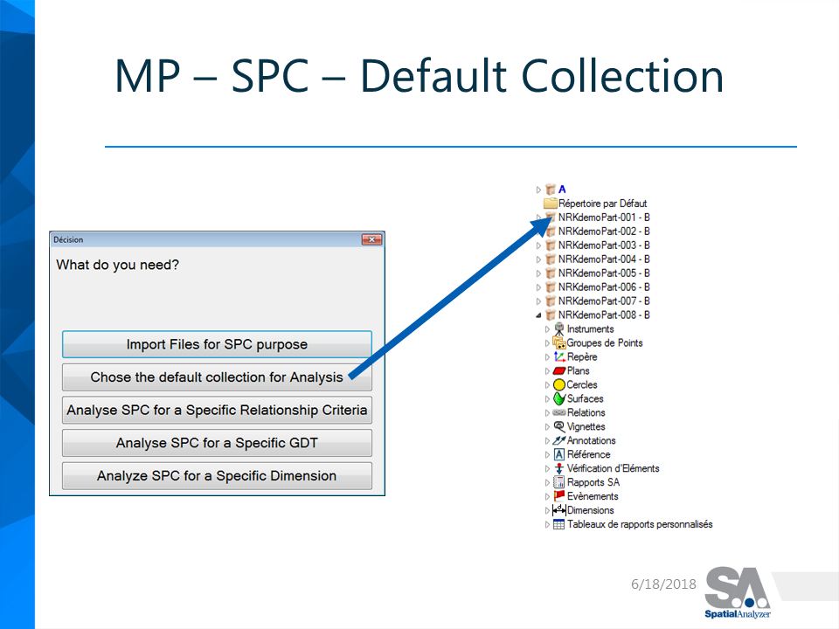
And chose what you want to watch closely :
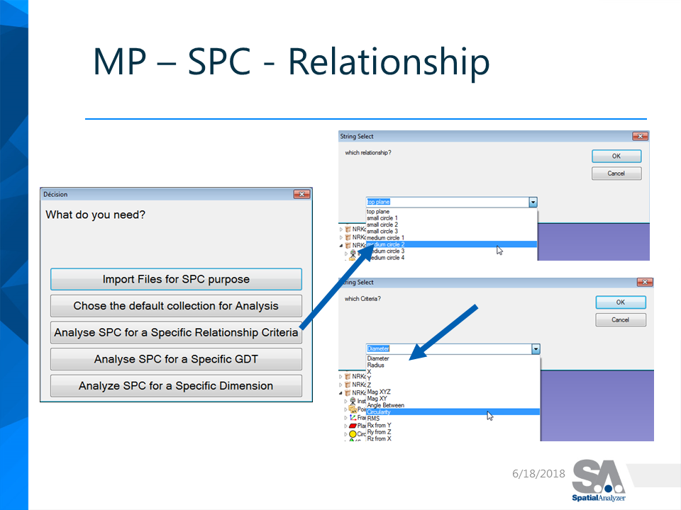
Thus, you have the Statistics analysis on your Process.
After, you can change one variable: keep same instrument, same part, but change 10 times your operator. You will see if your Process if sensible to your operator. Do as much test you need to check each variable you want to control, then you can said you have made Statistic Process Control: SPC.

The last variable you want to control, is your part production. After each N number parts measured, you can run this SPC tool, and check how your measurement move inside tolerance. You will be able to see for example a hole becoming smaller and smaller… still inside tolerance. That’s probably the drill becoming too used. You will be able to change it before your diameter is out of tolerance.

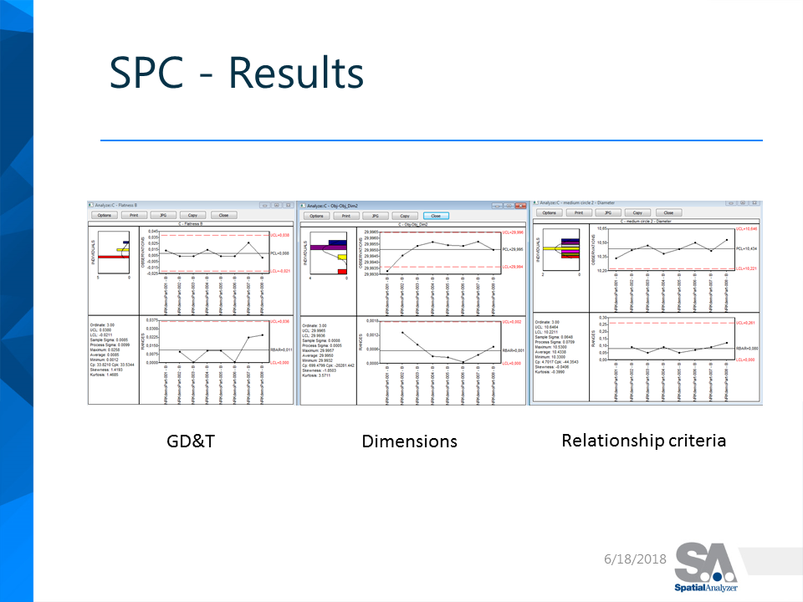

Thus, SPC helps you to understand your process and clear variability of each parameter to have a stable process. Moreover, SPC assists you to detect changes in production, and allow you to act before it’s too late.

