API XD Laser Rail in SpatialAnalyzer

The XD Laser is an Auxiliary Device in SA. To use the interface, add the Laser Rail to SA like any other instrument. Upon running the interface, the usual instrument log on dialog will appear with parameters specific to the XD.

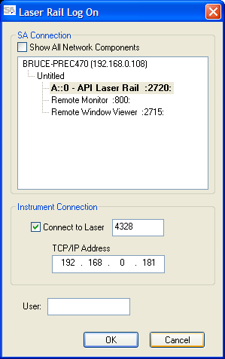

Select the laser (prm file name), and the ip address of the laser, and press OK. Note: You may also simulate the laser rail simply by un-checking ‘Connect to Laser’ and pressing ok. Once connection and initialization are complete, the main interface window will appear.

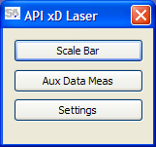

To set up the XD, press the Settings button for options.

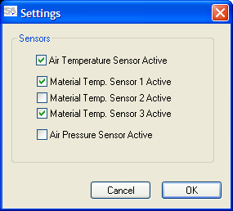

Adjust to desired settings, and press OK. The selected settings will be persisted for the next run of the laser.

Now, scale bars can be created, or Auxiliary data measurements can be made. To create scale bars, press the Scale Bar button for the Scale Bar interface.

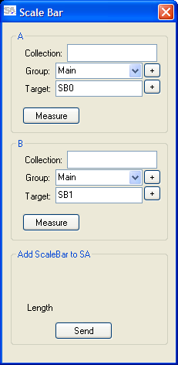

As with other instrument interfaces in SA, the Collection will default to “A” if left blank. Group and target names can be incremented by pressing the associated ‘+’ buttons. To create a scale bar, simply adjust names as desired, move the target to desired positions, and Measure each one. Whenever there is enough data to make a scale bar, the results to be sent to SA will be shown in the ‘Add ScaleBar to SA’ section of the interface window.

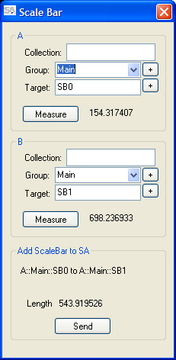

Just press ‘Send’ to send the scale bar to SA. (In this example, the interface is showing units of mm, and SA is showing inches.) In SA, under User Options, view the Scale-Bar Database to see the new definition.

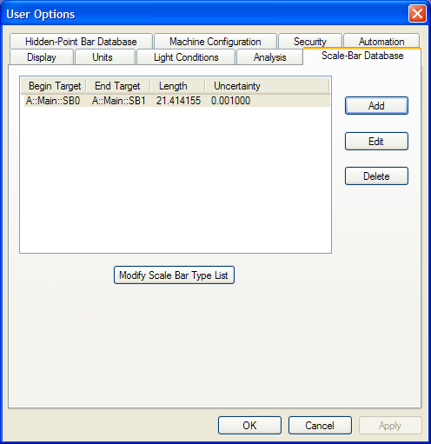

Continue building scale bars as desired.

To add 1-D auxiliary data measurements to SA, close the Scale Bar dialog, and press ‘Aux Data Meas’ in the interface. The Aux. Data window will appear.

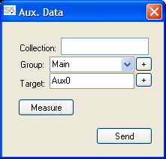

To record the laser rail distance, press Measure. The measurement will appear.

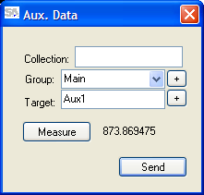

To send a measurement, simply adjust its name as desired, and press Send. The data will appear in the SA tree view. (Also in this example, the interface is displaying mm, and SA is showing inches.)

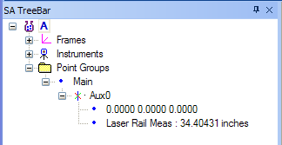

Continue measuring 1-D data points as desired.

