Quick Start Notes for Virtek Laser Projector in SA

First, make sure your projector has current software/firmware installed. For example, at the time of this writing, the onboard projector software version needs to be 5.5.0.1, which is compatible with the current Virtek PDK (projector dev. Kit) v. 1.6.0.17. Also, your pc must have .NET 2.0 installed, available from http://www.microsoft.com/downloads/, and .NET 2.0 SP1 (Service Pack 1). And finally, if you are running a parallel projector, you must have Virtek’s GiveIO parallel driver installed.

NOTE: As of April 2009, there is an incompatibility between the Virtek projector and the Metris Laser Radar and Surveyor. To run the Virtek projector, you must find the files ‘log4net_v 1.2.9.0 for Virtek Projector.dll’ and ‘log4net.dll’ in the SA install. Rename ‘log4net.dll’ to e.g. ‘log4net_v 1.2.10.0 for LR and Surveyor.dll’. Then rename ‘log4net_v 1.2.9.0 for Virtek Projector.dll’ to ‘log4net.dll’. The projector interface will now run.

Start SpatialAnalyzer and add a Virtek Laser Projector. Even if you are running several projectors, add only one model in SA. The projector model in SA is capable of representing all your projectors as a single context. Run the Laser Projector interface. As with any instrument, you’ll see the Logon dialog first.

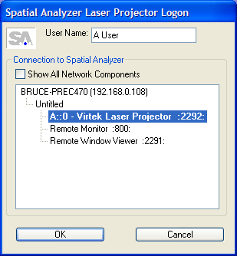

Select the Laser Projector as shown. The Laser Projector interface window will be shown.

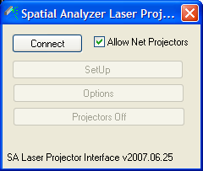

If you wish to connect to any network projectors, check ‘Allow Net Projectors’. Press ‘Connect’ to search for available projectors. Once any projector is found, you’ll here a sound and the ‘SetUp’ button will become enabled. Press ‘SetUp’ when enabled. The Available Projectors/Configuration window will be shown, displaying the serial number(s) of all projectors found.

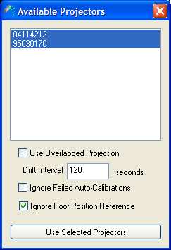

If there is only one available projector, the ‘Use Overlapped Projection’ check will have no effect. If more than one projector is to be used, then checking ‘Use Overlapped Projection’ will ensure that all projectors attempt to project all parts of all projected entities. Otherwise, the projectors will share the load by automatically clipping projected entities. As long as this Available Projectors window is up, any network projectors that become available pop in. NOTE: Ignore Poor Position Reference is checked in this case. This forces calibration to succeed, even in demo type situations where calibration point locations may not be ideal.
Select the projector(s) you wish to use, and press ‘Use Selected Projectors’. The Context Set Up window will appear.

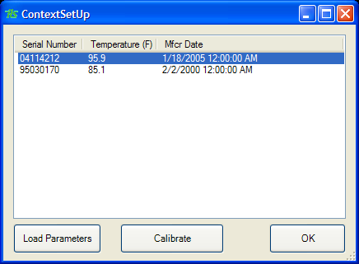

This is where the final setup/calibration takes place. For modern network projectors, the projector parameters are persisted on the projector. For older parallel projectors, the parameters are persisted on the pc. If your projector needs to have the parameters loaded, the ‘Calibrate’ routine will let you know. If you are in doubt, just press the ‘Calibrate’ button. If calibration can occur, it will, if not, you’ll be prompted for the *.cal Virtek projector parameters file for your unit. If you know parameters are needed, you can press ‘Load Parameters’ and locate the parameters file. Press the ‘Calibrate’ button. You’ll be prompted for the Virtek calibration file (ASCII file containing sets of Cartesian coordinates and corresponding galvanometer coordinates). Once calibration is complete, press ‘OK’ and the projectors are ready to use, or OK without running a calibration and calibrate from SA (described below). Once calibrated, the projector models in SA will match reality.

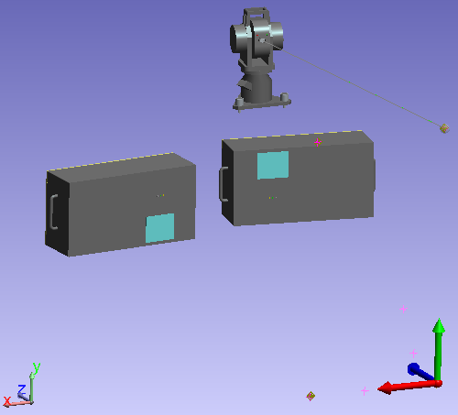
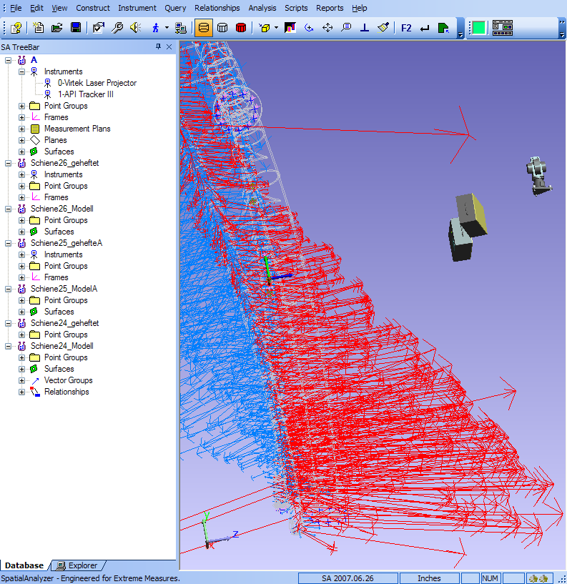
Back in the main dlg, the new Options button becomes enabled once there is a context, so user can edit general settings even after everything is up and going. The Projectors Off button is simply a way to toggle projection of the current entity set.

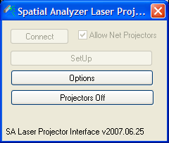

Options button pops this...
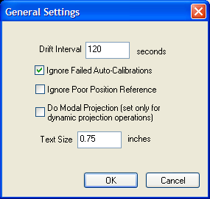

Any time a Watch Window is run, all calibrated projectors in the job will be used to project the arrow showing the direction, and the magnitude distance to the watched point or object. This is a good case for leaving ‘Use Overlapped Projection’ (described above) unchecked, so that only the projector in the best position will be used to project the arrow and the magnitude text.

In the Spatial Analyzer Instrument menu, select ‘Laser Projector’. You’ll see 3 options:

Calibration – This is a point based calibration (no galvo coordinates) which can be performed directly on points in SA. When this is used, you’ll see the Guided Calibration window.
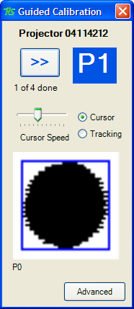
This guides you through locating each point with the mouse, or tracking a reflective target. The graphic shows the returned reflection from each target, to check/ensure that each has a reasonable angle of attack. The ‘Advanced’ button provides several additional options, such as selecting a saved Virtek cal file (with galvo coordinates), as well as creating a Virtek cal file.

Projection – This is the primary function. Select Projection, and you’ll be prompted to select objects (points, geometries, etc.) to project. So long as the projector has a clear shot, the objects will be projected.

Paint Measurements Dynamically – This provides a projection which follows the path of an instrument target’s center point as it is moved through the projector’s usable frustum.

To use this, make certain that ‘Do Modal Projection’ is checked in the projector Options. Then, you must locate the instrument and projector in a common reference frame. For the projector, you can simply calibrate to a file, then import that (ascii) file into SA. You can then measure the calibration locations with the instrument, and do an SA Best Fit, using the calibration points as nominals, to bring the instrument into the projector’s coordinate system.

Once co-located, the projector is ready to trace the instrument’s target. In the SA Instrument menu, select Laser Projector >> Paint Measurements Dynamically. You will be prompted to select the Laser Projector (you can select from the TreeBar on the left), and then the instrument. Once selections are made, you will see the Paint Measurements dialog…
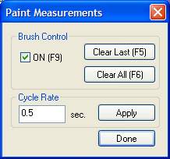
Now, put the instrument in a scanning mode, and all measurements which can be seen by the projector will be projected.
Brush Control ON (F9) toggles the ‘brush’. In other words, the laser is accepting data and projecting while this is checked, and ignoring incoming data when it is unchecked. Each time this control is unchecked and then re-checked, a new ‘block’ of data begins.
Brush Control Clear Last (F5) removes the last ‘block’ of data collected while the brush was ON from the projector’s display list.
Brush Control Clear All (F6) clears all projection.
The Cycle Rate is the rate at which the instruments measurements will be sent to the projector. 0.5 seconds is a good default, and the number should be raised only for very large point sets.

